New Light Baptist Church

FEBRUARY 23, 2020
YOUTH SUNDAY

WORSHIP LEADER ZIN CAMBRIDGE
INVOCATION

** HYMN OF PRAISE

WELCOME
ANNOUNCEMENTS amanda fuselier

PASTORAL Remarks
Congregational Fellowship
WORSHIP THROUGH DANCE

worship through music

Worship Through Giving
Song of Preparation
The Preached Word
Rev. Corey T. Bland, Pastor

* The Call to Salvation, CHRISTIAN Discipleship & Church Membership

* PRAYER & ALTAR CALL
BENEDICTION

*CONGREGATION STAND
**WORSHIPPERS MAY ENTER
Shining thru Social Media
As a church who believes in sharing the Word of God,
we encourage you to share worship highlights
using #LessonsFromTheLight on Twitter and Facebook.
Follow us at @NLBCRichmond on Twitter!
NOTICES & ANNOUNCEMENTS
MID-WEEK SPIRITUAL BOOST
Take 10 minutes out of your day each Wednesday at 12:30 p.m. to connect with other members of the NLBC Family through prayer over the phone line. To participate, all you have to do is call (605) 313-4829 and use the Access Code: 102493#. It's that simple.

BLACK HISTORY POTLUCK
We will celebrate Black History, by enjoying a Potluck Dinner TODAY, following service. Let’s come together to fellowship over a delicious meal.

EXECUTIVE BOARD MEETING
The Executive Board will meet on Monday, February 24th at 7:00 p.m. All members of the Executive Board are asked to attend.

ASH WEDNESDAY SERVICE
Ash Wednesday Service will be held at NLBC on Wednesday, February 26th at 7:00 p.m. Please plan to attend.

USHERS UNION DUES
The annual dues for the Ladies Usher Union of Richmond and vicinity are due on Sunday, March 1st. Dues are $24.00. Please submit your payment to Trustee Jane Parker. Checks should be made payable to NLBC.

PASTORAL ENGAGEMENT
Please join Rev. Bland, NLBC Choir and Ushers on Sunday, March 1st as he will be the guest Speaker for the Usher’s Anniversary at Mount Carmel Baptist Church. The service will begin at 3:30 p.m. Please come out and support our Pastor as he is sure to deliver an awesome message!

USHERS MINISTRY
Virginia State Baptist Ushers Union will have their annual mid-session Saturday, March 21st at 9:00 a.m. at Rising Mount Zion Baptist Church located at 2705 Hartman St. Registration forms are located in the Fellowship Hall. Please see Dea. Rogers for more information.

BULLETIN ANNOUNCEMENTS
All announcement notices to be included in the bulletin are to be sent to the church’s e-mail no later than Wednesday, 12:00 noon. Please include the term “Bulletin Announcement” in the subject line. Please see Dea. Rogers if you have any questions.

NOTICES & ANNOUNCEMENTS
HBCU DAY
Calling all HBCU attendees and graduates. Want to get our upcoming youth and college attendees excited about the prospect of attending an HBCU? We are looking for your support to develop an HBCU day in the near future. Your ideas and support are much needed. If you attended or graduated from an HBCU please reach out to Deaconess Eileen Hopson, Deaconess Gail Scruggs, or Dr. Patricia Rascoe.

MUSEUM OF AFRICAN AMERICAN HISTORY AND CULTURE
The trip to the museum is Sold Out! On behalf of the Women's and Youth Ministries, thank you. For those who are attending, we will load the Victory Travels bus on March 28th at 7:30 a.m. and will depart NLBC at 8:00 a.m. to travel to the museum. Please remember to dress comfortably. Although snacks will be provided on the bus, lunch will be on your own once we arrive at Potomac Mills Outlet Mall. Donations are still being accepted to defray the cost for our youth. Please see Deaconess Dr. Ann Harris to make your donation.

IMPORTANT INFORMATION
Any member that may have a question or concern is asked to email the church at newlightbaptistchurch@verion.net. Rev. Bland or a member of the Executive Board will contact you once your email has been received.

NLBC CHURCH DIRECTORY
NLBC It’s time to update our church directory! EVERYONE that would like to be included in the directory is asked to fill out the form located in the bulletin. This will also update the One Call Message system which keeps members informed of important church business and events. Please return the completed form to Sis. Pamela Thomas.

NEWS YOU CAN USE
Be sure to stop in the Fellowship Hall to view the “News You Can Use” bulletin board. You will find several items of interest each month which will include topics on health issues, community happenings and other pertinent information. For more information or to place something on the board please Dea. Haywood Rogers or Sis. Pamela Thomas.

INTERCESSORY PRAYER LIST

“I urge, then, first of all, that requests, prayers, intercession and thanksgiving be
made for everyone”— (I Timothy 2:1)

Rev. Corey T. Bland & Family Min. Kevin Dixon & Family
Dea. Arthur Thornton & Family Bro. Rodney Thomas
Bro. Dale Cottrell & Family Dea. John & Deaconess Flora Green Sis. Betty Whitfield Sis. Alease Harrold
Trustee Alton King Sis. Jacqui Massey
Trustee Harold Waddy & Family Bro. John Lambert & Family
Sis. Linda Valentine Sis. Lorraine Robinson & Family
Rev. Sylvestine Branch & Family Sis. Shirley Taylor
Trustee Jane Parker & Family Sis. Kathy Emanuel & Family
Dea. Andy Johnson & Family Sis. Elnora Revens
Dea. Andrew Hopson & Family Sis. Pamela V. Thomas & Family
Sis. Ercelia Mayo Bro. Terence & Sis. Sandra Singleton Trustee Betty Johnson & Family Trustee Jake Holt & Family Sis. Starlene Pittman Persons on Our Prayer Wall
Our Pastoral Families and All Ministries of New Light Baptist Church

PLEASE REMEMBER TO PRAY FOR THESE FAMILIES & MINISTRIES
UPCOMING ACTIVITIES

Mon., Feb. 24th Executive Board Meeting, 7:00 p.m.
Tues., Feb. 25th Trustee Meeting, 6:30 p.m.
Wed., Feb. 26th Ash Wednesday
Joint Ash Wednesday Service, 7:00 p.m.
Thurs., Feb. 27th Choir Rehearsal, 7:00 p.m.
Sat., Feb. 29th Choir Rehearsal, 7:00 p.m.
Sun., March 1st Ladies Usher Union Dues, Due
Rev. Bland to Mt. Carmel Baptist, 3:30 p.m.
Mon., March 2nd Dea. Ministry Meeting, 7:00 p.m.
Wed., March 4th Bible Study
Thurs., March 5th Choir Rehearsal 7:00 p.m.
Fri., March 6th Employee Appreciation Day
Sat., March 7th Men’s Ministry Meeting, 9:00 a.m.
Choir Rehearsal, 10:00 a.m.
Sun. March 8th Daylight Savings Time
Children’s Church
Greeters Ministry Meeting, following service
Mon., March 9th CEM Board Meeting, 6:30 p.m.
Wed., March 11th Bible Study, 7:00 p.m.

TRUSTEE ASSIGNMENT FOR THE WEEK
Week of February 23rd through February 29th is Trustee Russell Thompson.

Prayer for the Week: We pray for healing, strength for those who are caregivers and patience as we go through our trials. We ask God to continue to bless us as we praise Him through it all so that we may be able to tell our stories to help someone else. Amen.

NEW LIGHT BAPTIST CHURCH

Sunday School – 9:30 a.m.

New Member Orientation Classes –
3rd Saturdays – 10:30 a.m.

Prayer and Praise – 10:45 a.m.

Morning Worship Service – 11:00 a.m.

Holy Communion – First Sundays

Bible Study – Wednesdays – 7:00 p.m.

New Light Staff and Officers

Pastor – Rev. Corey T. Bland

Youth Minister Rev. Erica Daniels

Deacons, Chairperson Deacon Haywood Rogers

Deaconess, Chairperson Deaconess Eileen Hopson

Trustees, Chairperson Trustee Jane B. Parker

Financial Secretary Deaconess Dr. Anjour Harris

Treasurer Trustee Betty Johnson

Christian Education Dr. Christine Fuselier

Audio/Video Ministry Ernest Kabushemeye

Children’s Church Tiffany Cambridge

Evangelism Ministry Vacant

Greeters Ministry Patricia Thompson

Head Usher (Emerita) Elnora Revens

Health Ministry Vacant

Kitchen Ministry Vacant

Men’s Ministry Deacon Anderson Johnson

Missionaries Diane Hall

Minister of Music Minister Kevin M. Dixon

New Members Ministry Pamela Thomas

Scholarship/Education Ministry Avis Harrold

Sunday School Superintendent Demetrist Waddy

Women’s Ministry Deaconess Dr. Anjour Harris

Young Adult Ministry Vacant

Youth Minister Rev. Erica Daniels

Special Events Coordinator Patricia Thompson
Outreach Coordinator Ashley Osborne

Administrative Assistant/ Pamela Thomas

Church Clerk

Webmaster Ernest Kabushemeye

Church website www.newlightbaptistchurch.org

Church e-mail address newlightbaptistchurch@verizon.net

Christian Ed. Ministry e-mail address CEMinfo@newlightbaptistchurch.org

_

_______________________________________________________________________________________________________________________

Audio/Video Ministry Request

Name: Phone: _________________________

Date of Service: AM ___ PM ___ Quantity________

Please circle your media selection below:
Cost: DVD - $15, Audio CD - $12, VHS tape - $10, Audio cassette - $5.
Sr.’s Cost: DVD-$12.75, Audio CD-$10.80, VHS Tape-$8.50, Audio Cassette-$4.75
Submit your order to Trustee Alton King or Deacon Andy Johnson
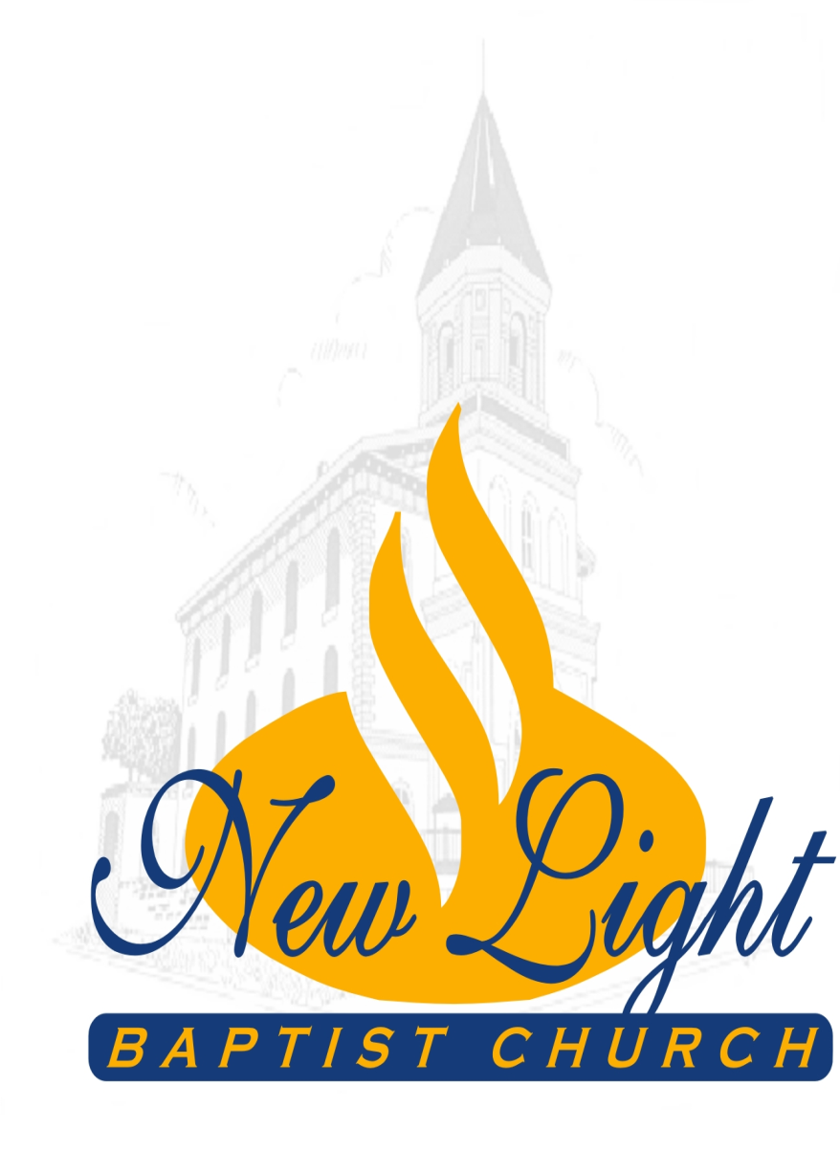

2000 East Broad Street

Richmond, Virginia 23223
(804) 788-9027

“Where All People Are God’s People”

Reverend Corey T. Bland, Pastor

